BUSINESS INSIGHT REPORT

DATESET NAME:
GLOBAL SALES & FINANCIAL PERFORMANCE
STUDENT NAME: PAVITHRA E

1. INTRODUCTION
This report presents a business intelligence analysis of the Global Sales & Financial Performance dataset, drawing on an interactive Power BI dashboard built from the FactSales table and its supporting dimension tables (DimCustomer, DimDate, DimEmployee, DimGeography, DimProduct). The purpose of this report is to translate the dashboard's key performance indicators and visuals into clear, actionable business insights covering overall sales and profitability, product category performance, monthly sales trends, regional distribution, and employee contribution. The findings are used to support data-driven recommendations for inventory planning, marketing strategy, regional expansion, employee performance management, product portfolio decisions, and customer targeting.

2. DASHBOARD OVERVIEW

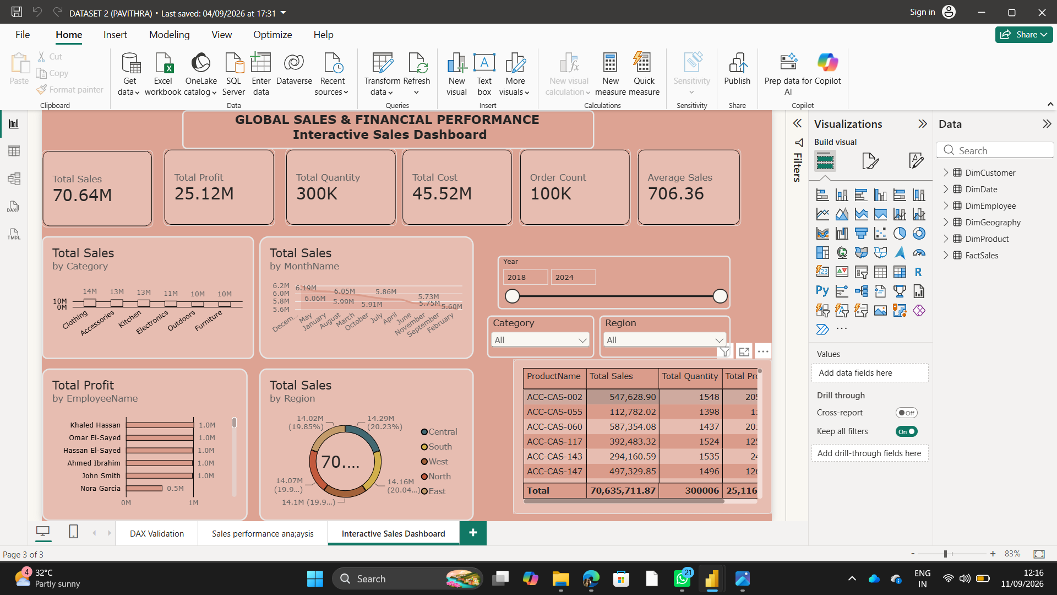

The Interactive Sales Dashboard consolidates the organization's global sales and financial performance into a single view. Six summary cards at the top report Total Sales (70.64M), Total Profit (25.12M), Total Quantity sold (300K units), Total Cost (45.52M), Order Count (100K orders), and Average Sales per order (706.36). Below the cards, the dashboard breaks performance down by product category, by month, by employee, by region, and at the individual product level, with slicers for Year, Category, and Region that allow the data to be filtered interactively.

3. KPI ANALYSIS
Total Sales  70.64M | Total Profit  25.12M | Total Quantity  300K
Total Cost  45.52M | Order Count  100K | Average Sales  706.36

The dataset reflects a healthy overall margin: profit of 25.12M against total cost of 45.52M implies a profit margin of roughly 35% on total sales of 70.64M. With 100K orders generating 300K units sold, the average order carries about 3 units, and the average order value of 706.36 gives a benchmark against which future pricing, discounting, and upsell strategies can be measured.

4. PRODUCT CATEGORY PERFORMANCE ANALYSIS

Total Sales by Category shows a relatively even spread across six categories, with Clothing leading at approximately 14M, closely followed by Accessories and Kitchen at around 13M each. Electronics trails slightly at about 11M, while Outdoors and Furniture are the smallest contributors at roughly 10M each.
● Clothing (~14M) and Accessories/Kitchen (~13M each) are the strongest categories and should be prioritized for stock availability.
● Electronics (~11M) performs moderately but may have higher unit value and lower volume, warranting a closer look at margin per unit.
● Outdoors and Furniture (~10M each) are the weakest categories, indicating either lower demand, seasonality, or an opportunity for targeted promotion.
● The narrow gap between the top and bottom categories (about 4M) suggests a diversified, balanced portfolio rather than dependence on a single category.

5. MONTHLY SALES TREND ANALYSIS

The Total Sales by MonthName trend line shows monthly sales fluctuating in a fairly narrow band, generally between 5.6M and 6.2M per month. This indicates stable, consistent demand across the year rather than sharp seasonal spikes or troughs. Small month-to-month variations are visible, with some months trending toward the higher end (around 6.0-6.2M) and others dipping toward the lower end (around 5.6-5.8M).
● Consistent monthly performance suggests demand is broad-based rather than driven by one or two peak seasons.
● The moderate dips in certain months are candidates for targeted promotions or campaigns to smooth out the sales curve.
● Because variation is modest, inventory and staffing can likely be planned on a fairly steady monthly basis, with only minor adjustments for the lower-performing months.

6. REGIONAL SALES ANALYSIS

Total Sales by Region is split almost evenly across five regions: West leads with 14.29M (20.23%), followed by North at 14.16M (20.04%), East at 14.1M (19.9%), South at 14.07M (19.9%), and Central at 14.02M (19.85%). The maximum gap between the strongest and weakest region is less than 2%, indicating a well-balanced geographic footprint.
● West and North are the top-performing regions and represent proven markets for continued investment.
● Central, South, and East are only marginally behind, showing largely untapped upside rather than underperformance.
● The even regional split suggests demand is not concentrated in one geography, reducing risk from regional economic downturns but also meaning growth will need region-specific strategies rather than a single national push.

7. EMPLOYEE PERFORMANCE ANALYSIS

Total Profit by EmployeeName shows that Khaled Hassan, Omar El-Sayed, Hassan El-Sayed, Ahmed Ibrahim, and John Smith each contribute approximately 1.0M in profit, forming a consistent top tier of performers. Nora Garcia contributes notably less, at approximately 0.5M, roughly half the profit of the other employees shown.
● Five of the six employees shown are performing at a comparable, strong level, suggesting consistent sales processes or training across the team.
● Nora Garcia's profit contribution is about 50% lower than peers, which may warrant coaching, a review of assigned accounts/territory, or further investigation into workload or product mix.
● Because most employees cluster tightly around 1.0M, best practices from top performers could be documented and shared to help lift any lagging team members.

8. BUSINESS RECOMMENDATIONS
Inventory Planning
● Maintain higher stock levels for Clothing, Accessories, and Kitchen given their consistently strong sales.
● Because monthly sales are stable rather than sharply seasonal, inventory can be planned on a steady monthly cadence with modest buffers rather than large seasonal builds.
Marketing Strategy
● Run targeted campaigns for Outdoors and Furniture to close the gap with the top categories.
● Use light promotions in the lower-performing months identified in the monthly trend to smooth demand across the year.
Regional Expansion
● Continue investing in West and North, the top two regions, to reinforce their lead.
● Explore growth initiatives in Central, South, and East, where sales are only marginally behind the leaders and may respond well to localized marketing.
Employee Performance
● Recognize and document the practices of top-performing employees (Khaled Hassan, Omar El-Sayed, Hassan El-Sayed, Ahmed Ibrahim, John Smith) for wider team training.
● Provide targeted coaching or support to employees such as Nora Garcia whose profit contribution trails the team average.
Product Portfolio
● Review high-cost, lower-sales categories (Outdoors, Furniture) for pricing, bundling, or assortment changes to improve their contribution.
● Evaluate top individual products (e.g., ACC-CAS-060 and ACC-CAS-002, the two highest-selling products in the table) as candidates for feature promotion or cross-selling.
Customer Targeting
● Use the balanced regional and category performance to build segmented customer campaigns rather than a one-size-fits-all approach.
● Leverage the order-level data (average order value of 706.36) to design upsell or bundle offers that lift average order value across all regions.

